Objectives

1. Installation
2. Basic terminology
3. Creating
4. Querying

# Installation

1. Go to site : <https://www.postgresql.org/>
2. Click on Download > Select OS
3. Click on “Download the installer”
4. Select the latest installer
5. When the installer is downloaded – select next,next
6. Enter the password – important
7. Click in next to download and complete it

Now your local computer is acting as a database server. Click on servers in top left and enter the password and you are connected to server. Explore the options

# Database terminologies

1. What is a database

* A logical container for storing a collection of data
* We have have one record, that has multiple attributes of a entity
* Example Student – name, address, class, age

1. What is DBMS

* Database management system
* Act as an interface between usres/apps and database
* Helps to translate and process query
* RDBMS : relational database management system (tables connected to each other)

We use SQL to manage data in relational database management

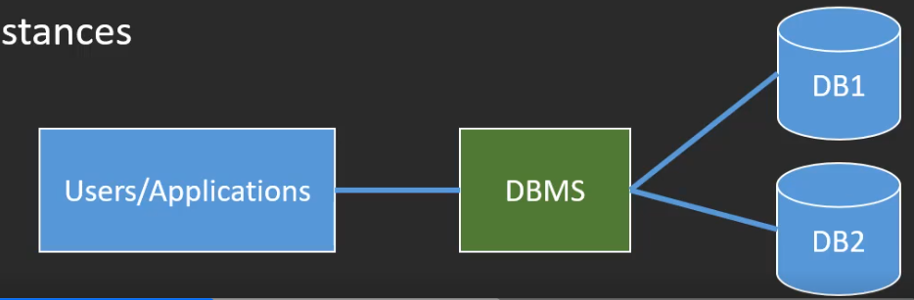

1. Primary and Foreign Keys

* If we have a table, primary key allows you to uniquely identify a single row in a table
* Helps identify a entity
* Defined when creating table
* 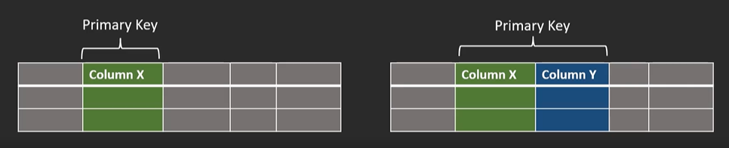
* Foreign key helps navigate from one table to another table
* It doesn’t need to be unique
* References a primary key in another table
* 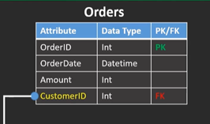 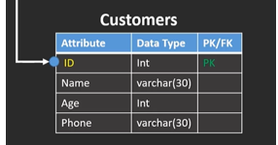

1. Relational Model

* Relational databases are a type of database that stores data in tables with rows and columns. Each table represents an entity, and each row represents an instance of that entity. The columns represent the attributes of the entity.
* Entity
  + Distinguishable, unique, and distinct
  + All entities from the same entity type will be managed under the same table
* Attribute
  + A characteristic of an entity
  + Stored under a dedicated column (relevant data type)
* Relationship
  + Describes association between different entities
  + One-to-many
  + One-to-one
  + Many-to-many
* ERD - Entity Relationship Diagram
  + Model and design relational databases

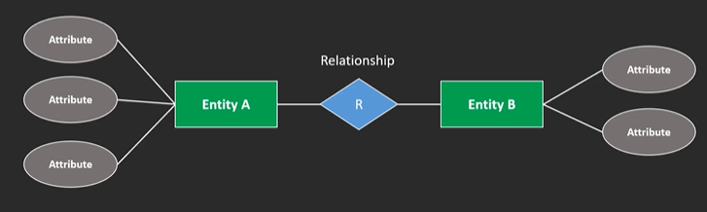

* Database logical Schema
* 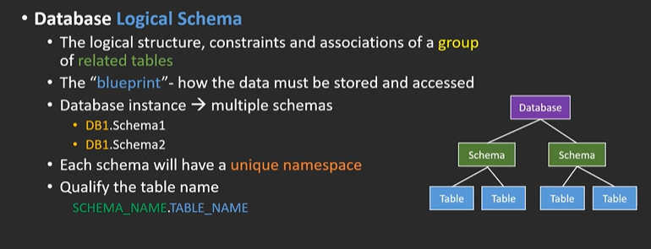
* Database catalog
* 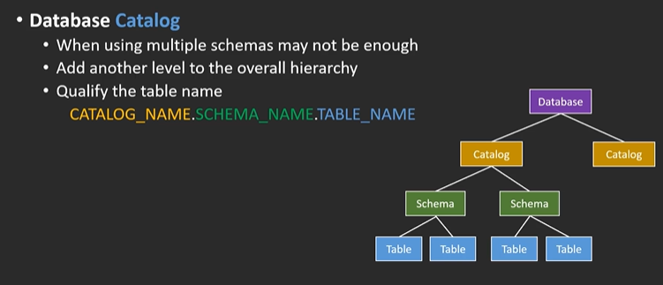
* 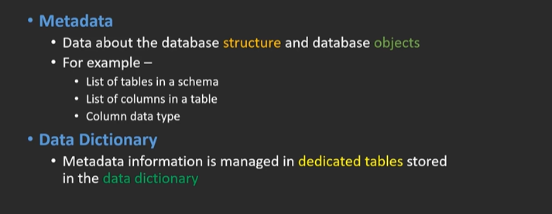
* Null Values
* 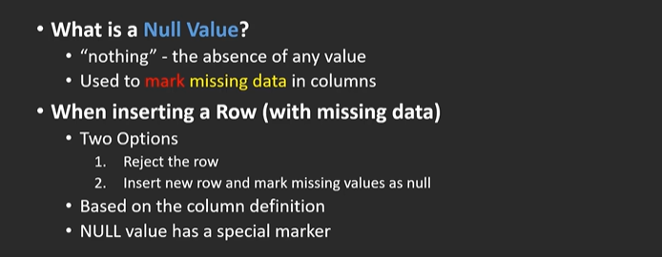
* Indexes

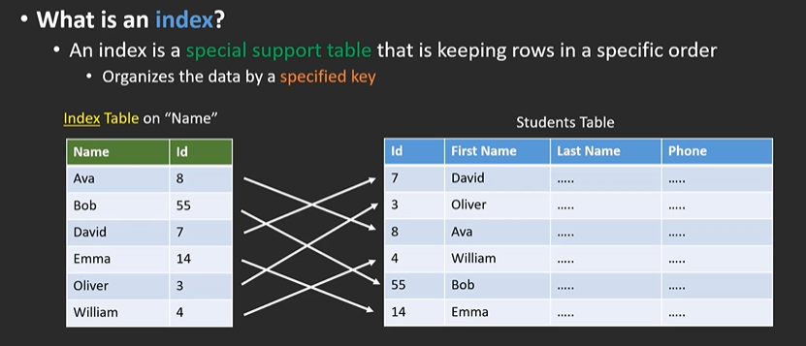

* Partition
* 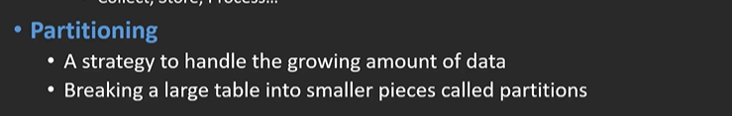
* 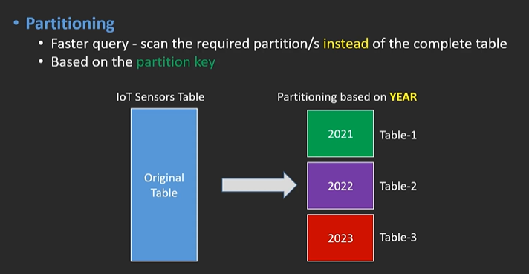
* 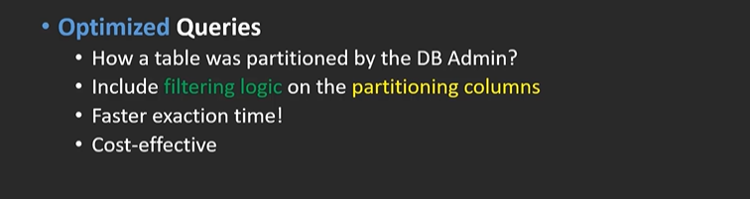

# Creating Databases, Schemas, and Tables

1. Enter the password and connect to server
2. Right click database > Create > Database  
   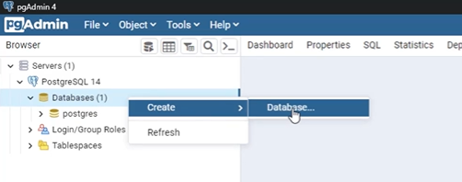
3. Enter the name, owner and commenet / or select Tools > Query and create using command

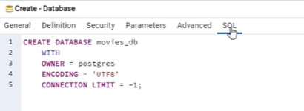 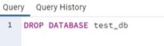

1. We can create schema by  
   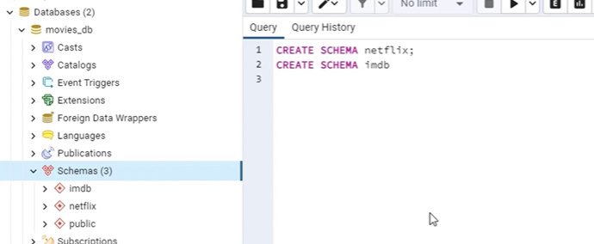

# How to give Default value to Table

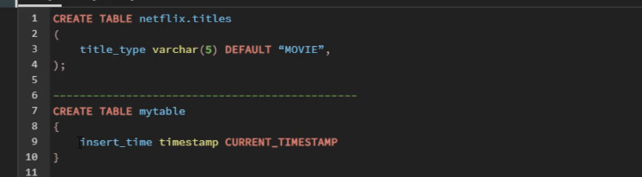

# Types of constrains

1. We say it cannot be null  
   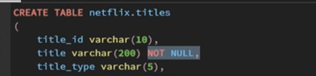
2. Check for a condition

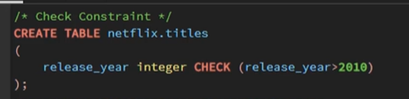

1. Unique

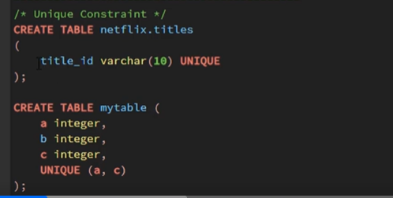

1. Primary key

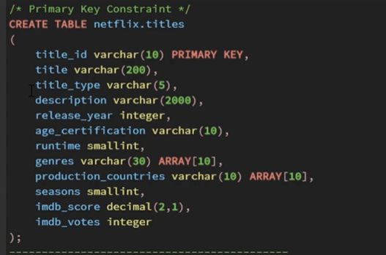

1. Foreign key

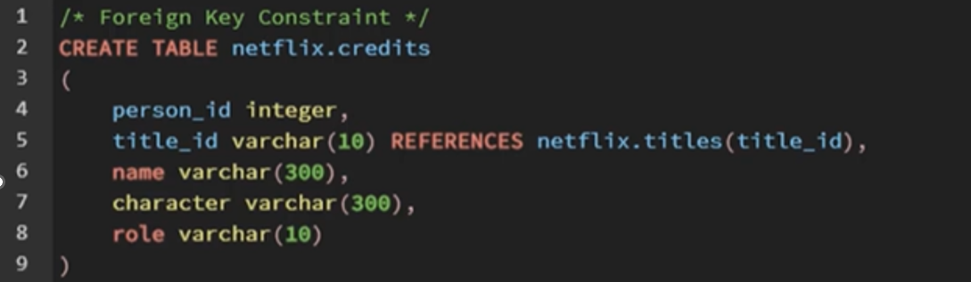

# How to insert data into table

1. INSERT command  
   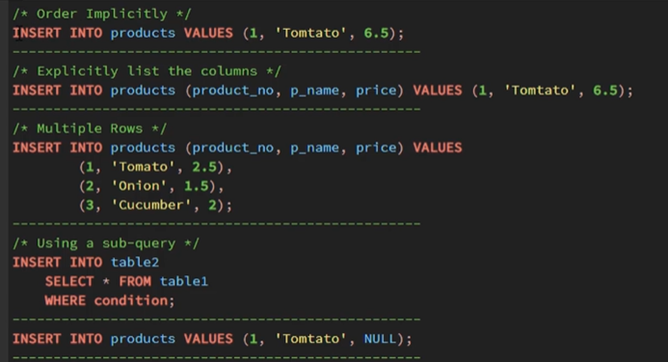
2. Import from file

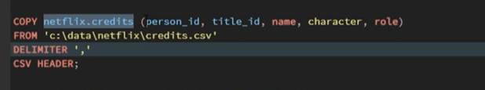

# Updating and deleting a table

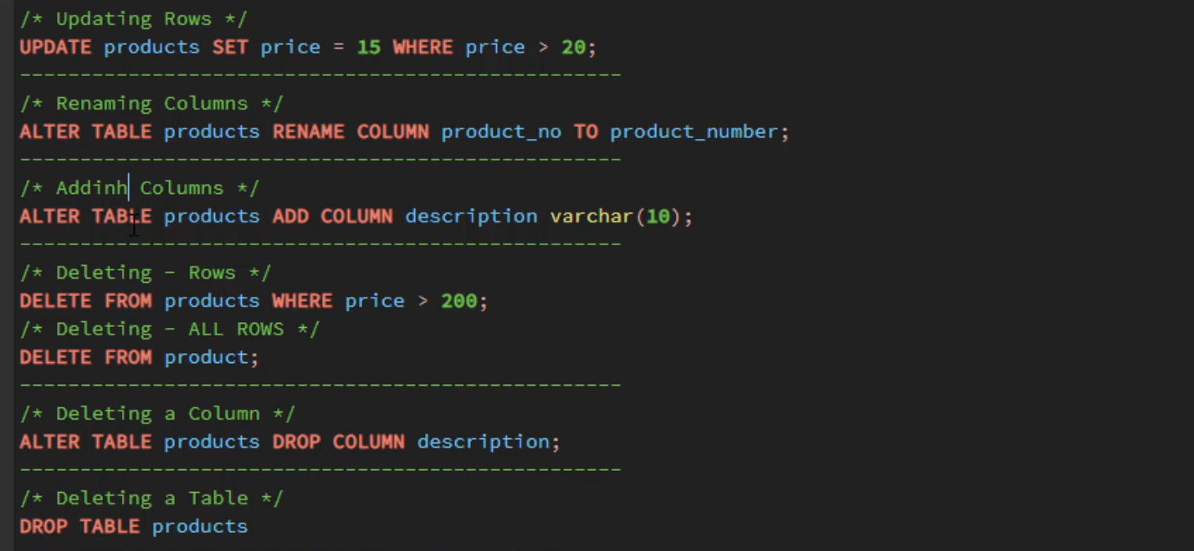

# Project 1 :

1. Create a Movies database

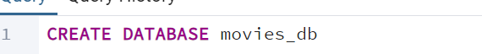

1. Create 2 schemas

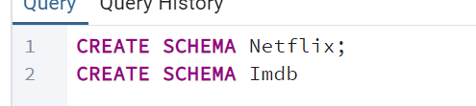

1. Create a table with primary key and foreign key :

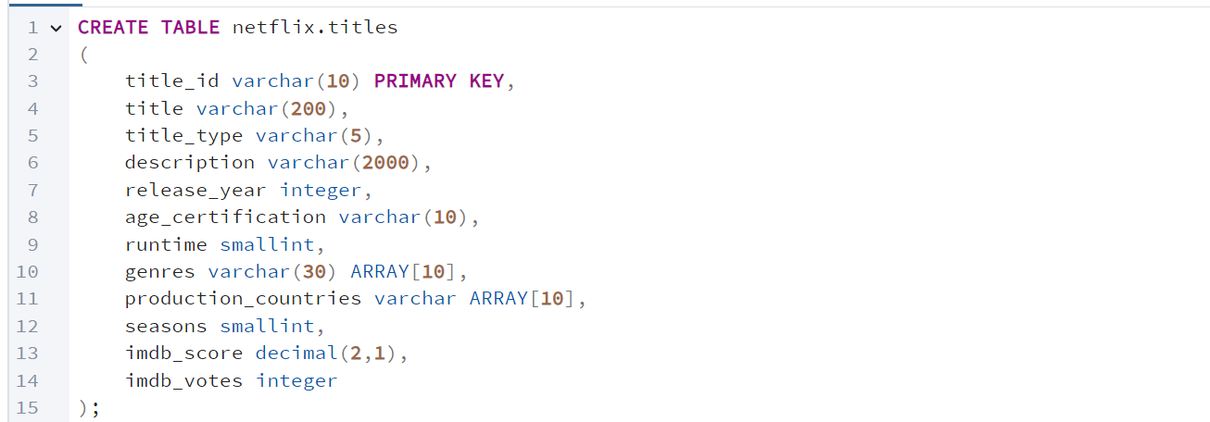

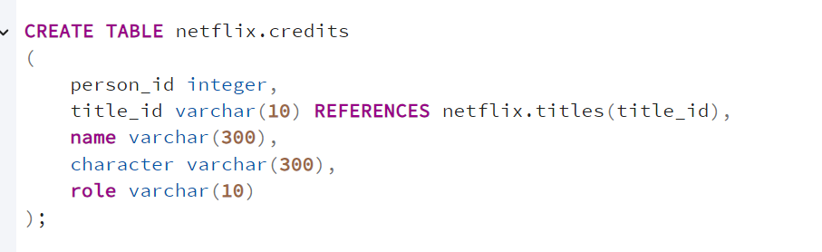

1. Now insert data into table from .csv files

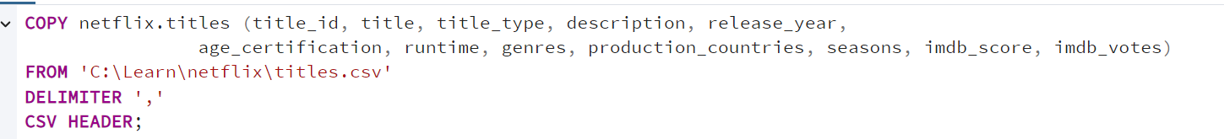

Types of tables

1. Regular stored table
2. Virtual table
3. Derived from another SQL query
4. Temporary table

Querying data

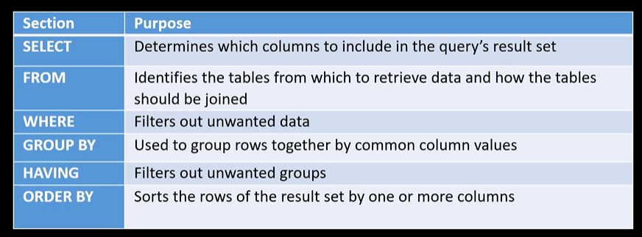

1. SELECT

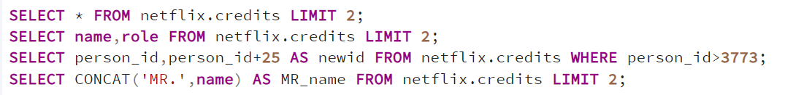

1. Where

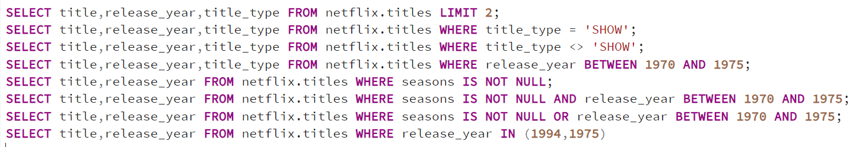

1. AS



1. Searching pattern



1. Distinct



1. ORDER BY



1. Group BY

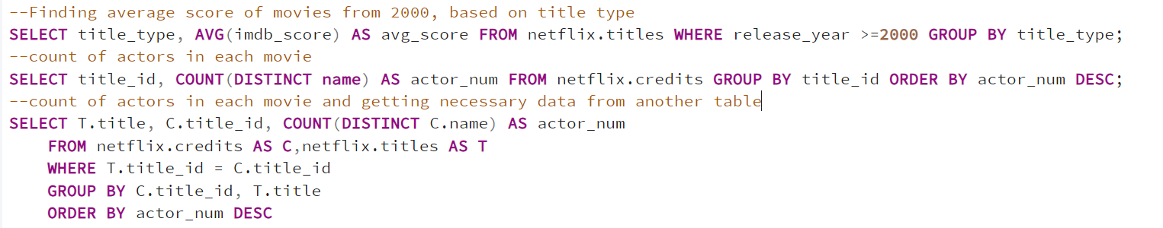

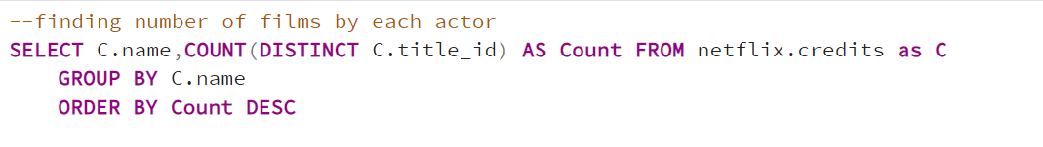

1. Having

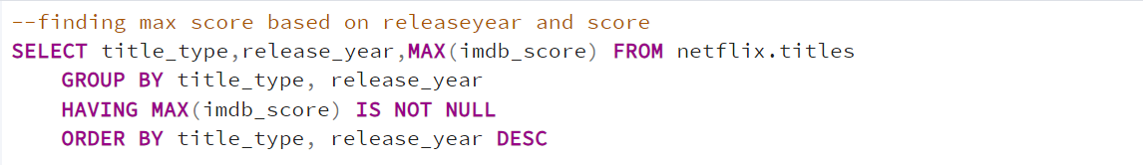

Order of execution

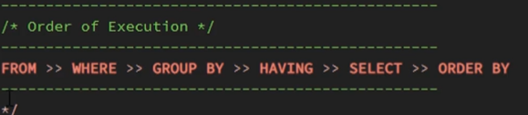

Type Casting --37

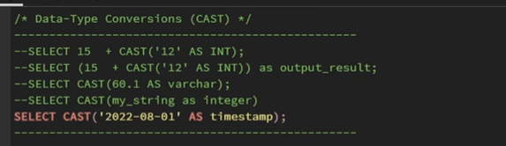

Querying Database structure with inbuilt functions

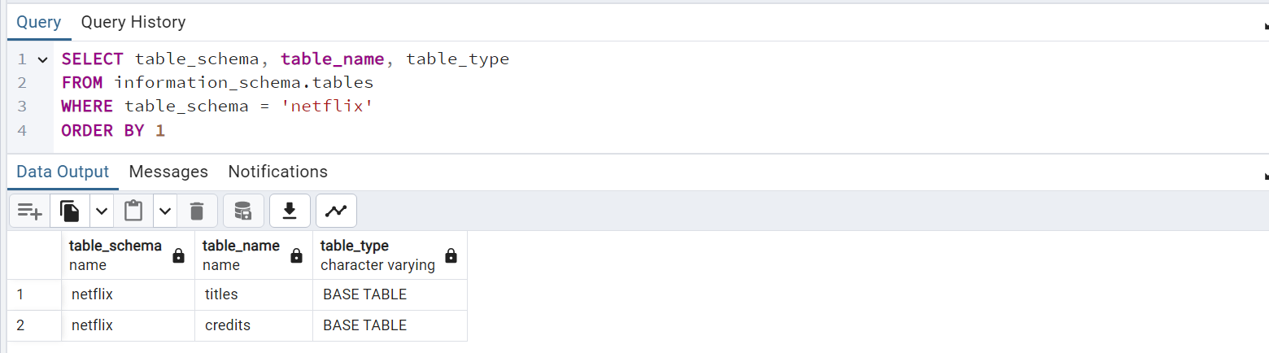

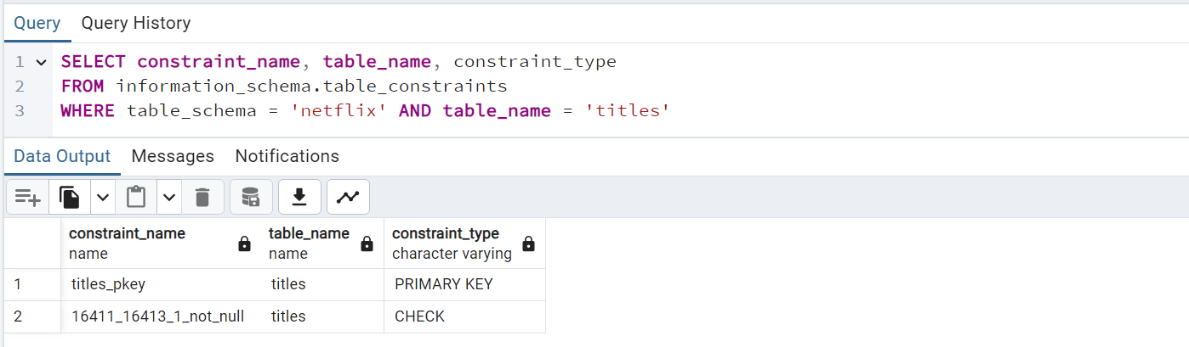

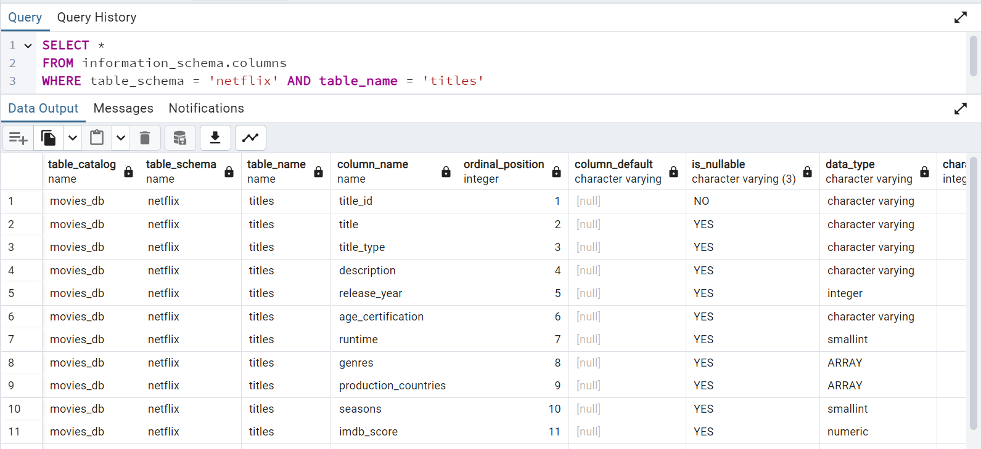

# Level 2

## **Project 2**

1. Create a database called Level2
2. Create a schema called book_schema  
   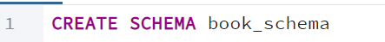
3. Create a table  
   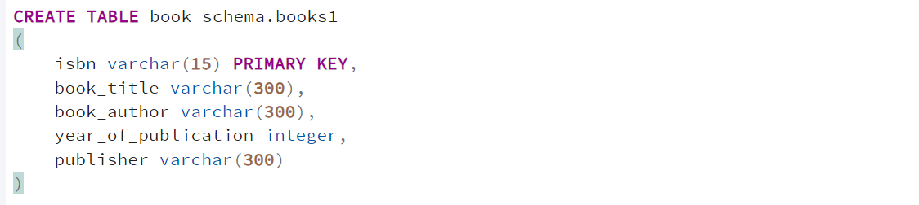
4. Upload data to the table  
   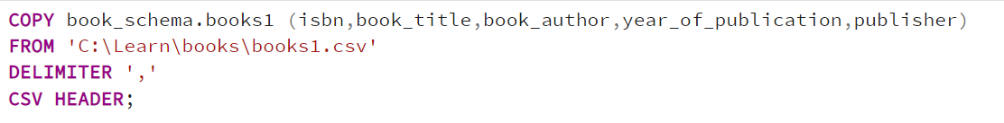
5. Similary do it for books2, user and ratings  
   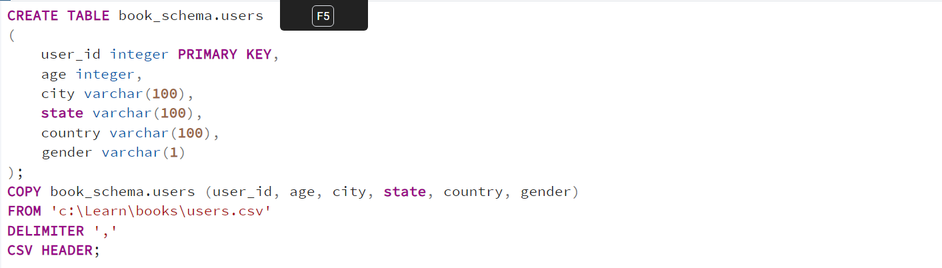

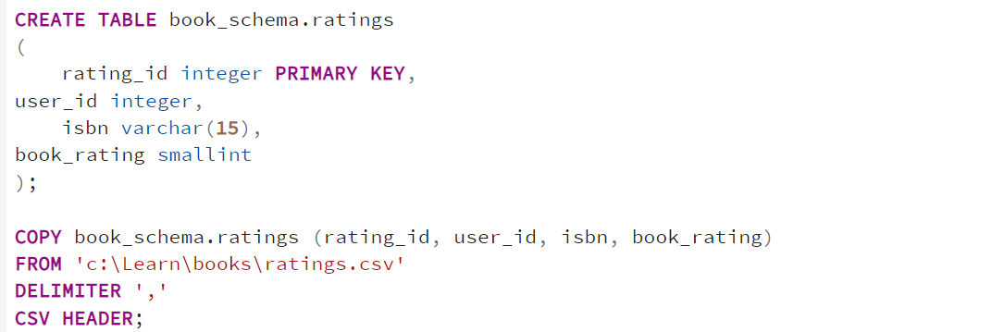

1. Similarly do it for Ecommerce

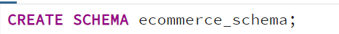

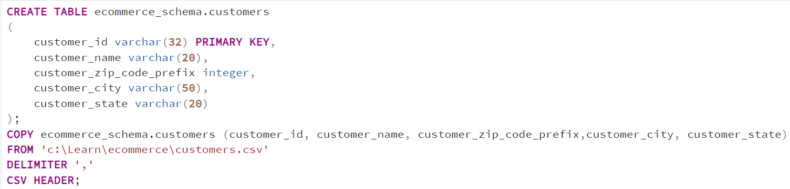

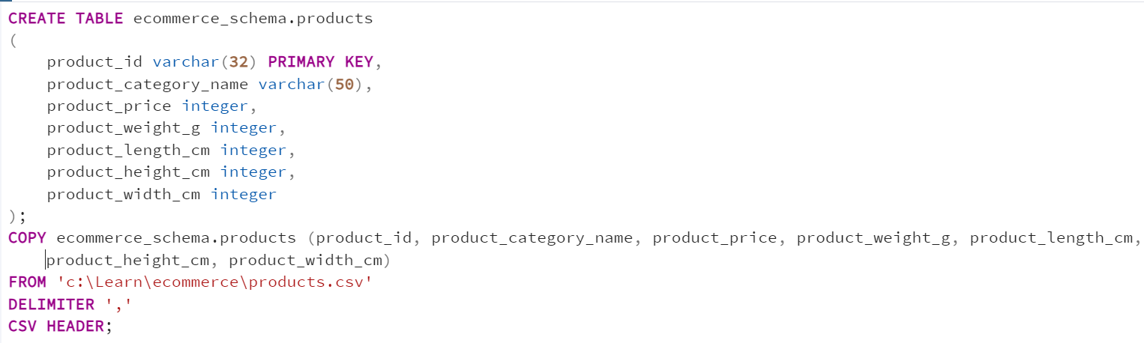

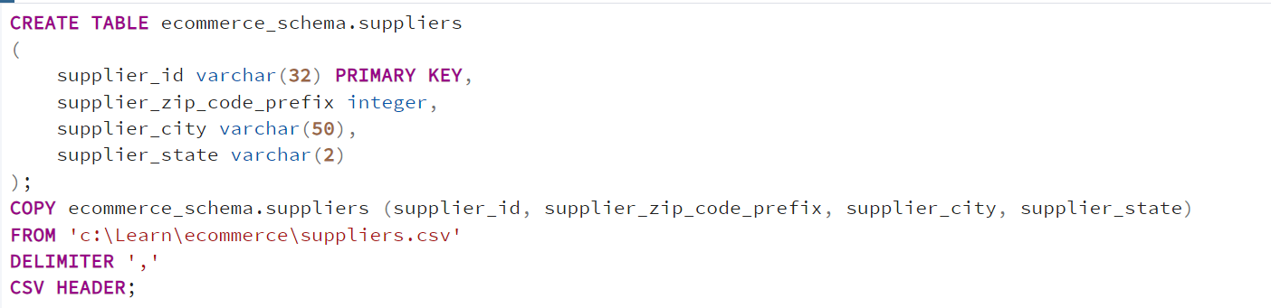

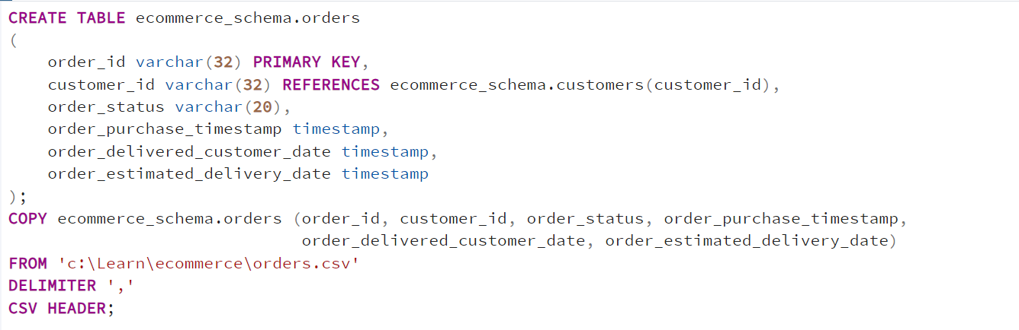

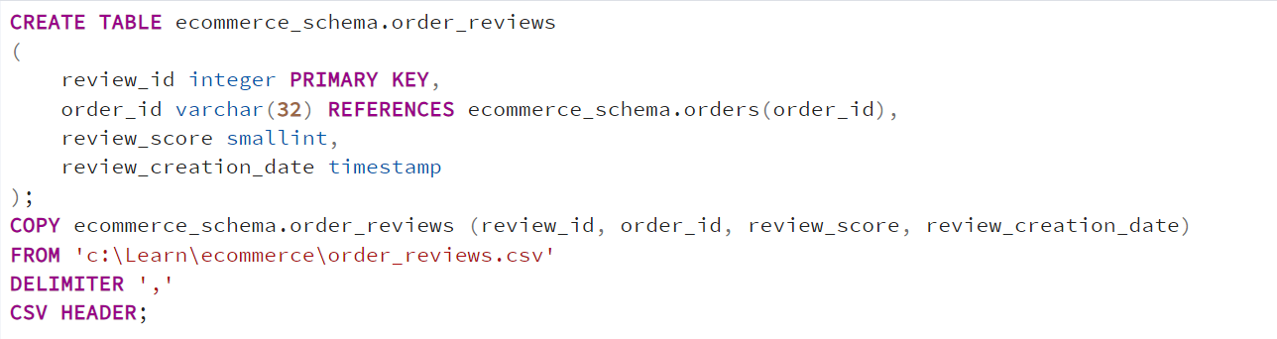

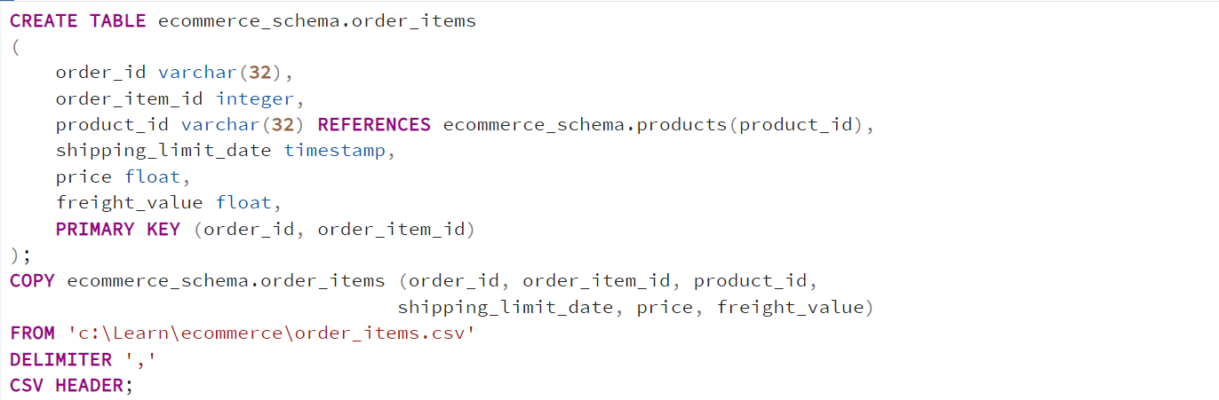

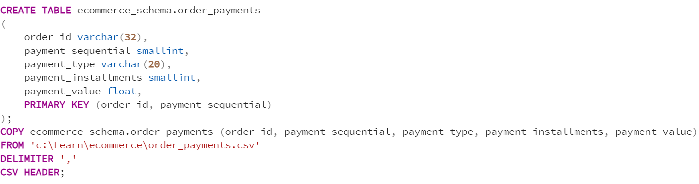

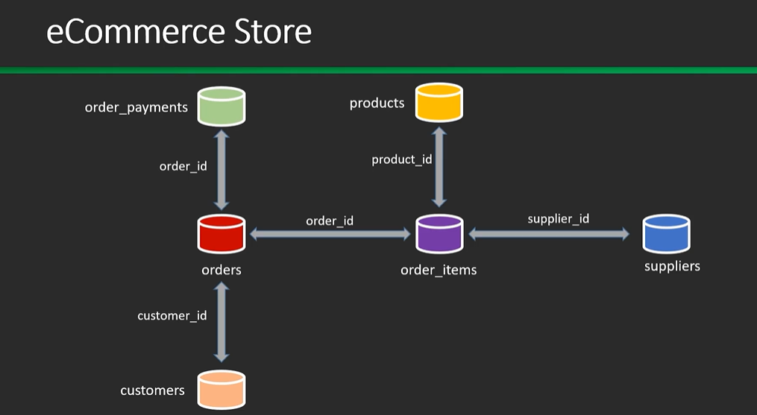

# Combine data from multiple tables

1. UNION

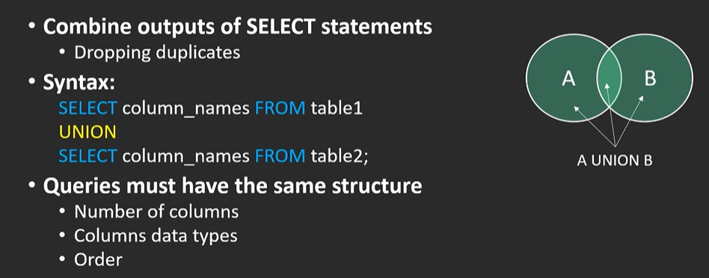

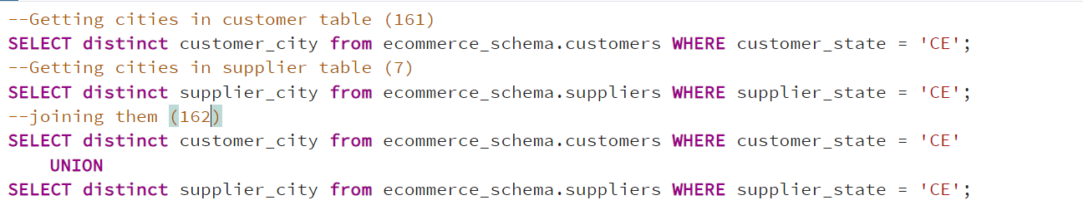

1. INTERSECT

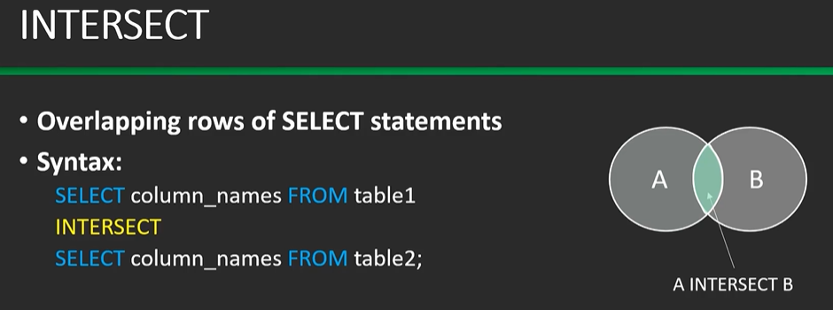

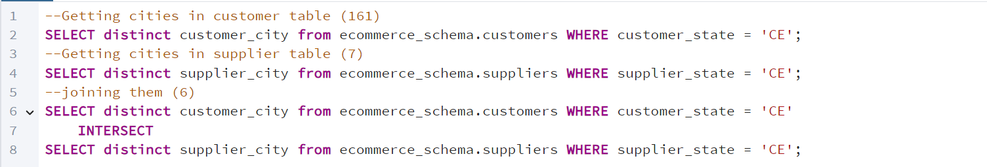

1. EXCEPT

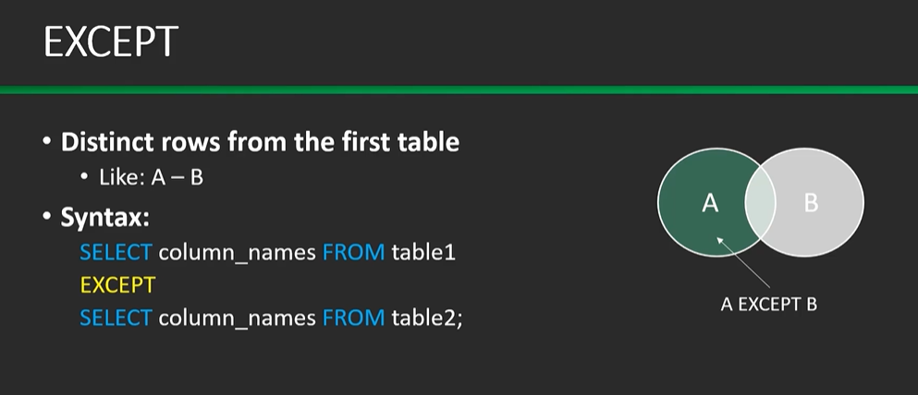

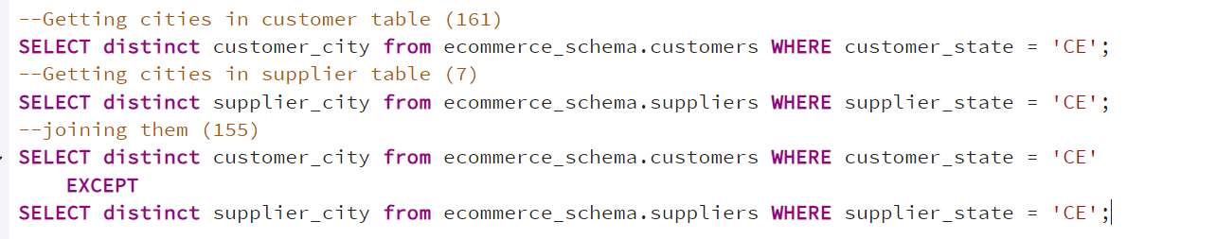

JOIN  
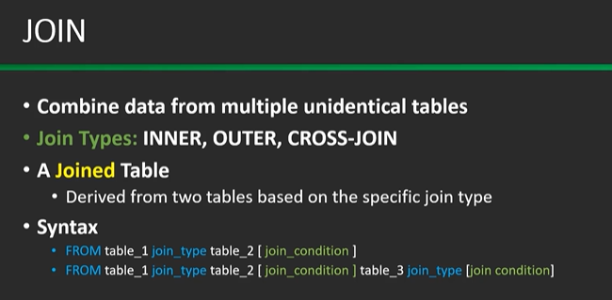

1. Cross join

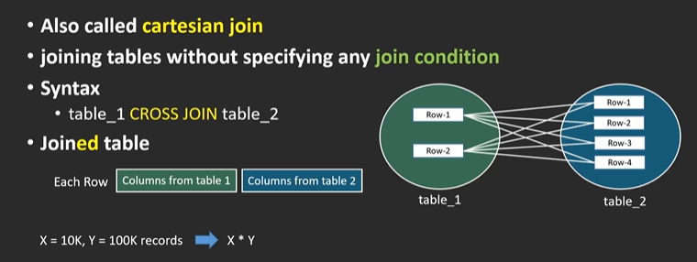

1. Inner Join (default)

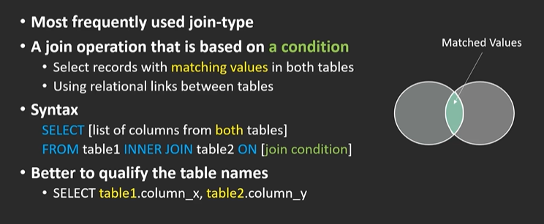  
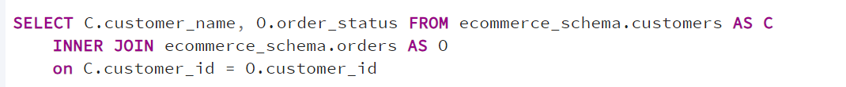

1. Outer Join

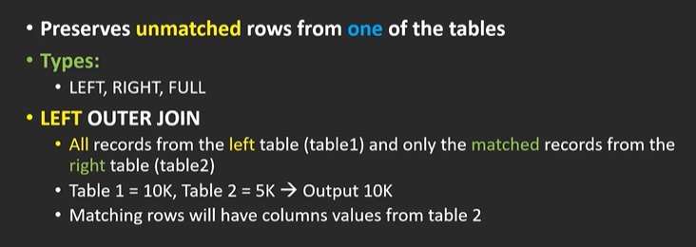

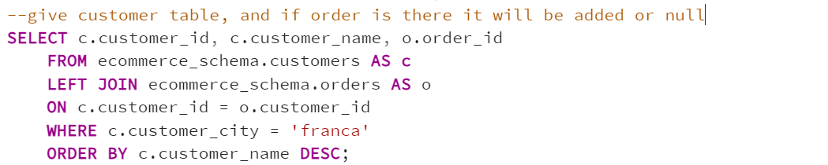

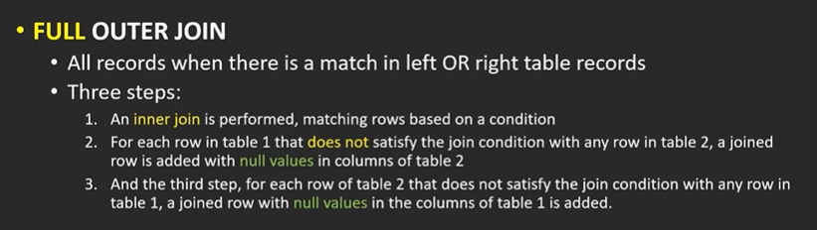

# SubQuery

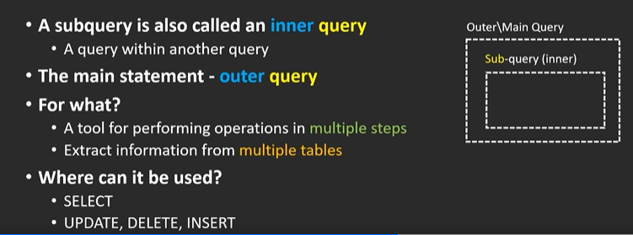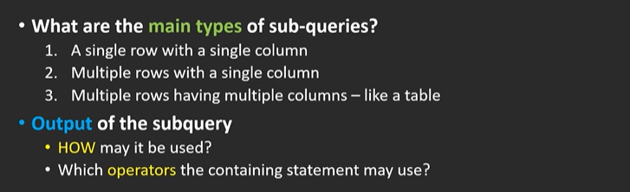

1. Conditional logic – single row

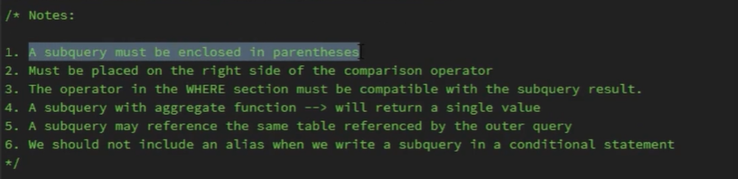

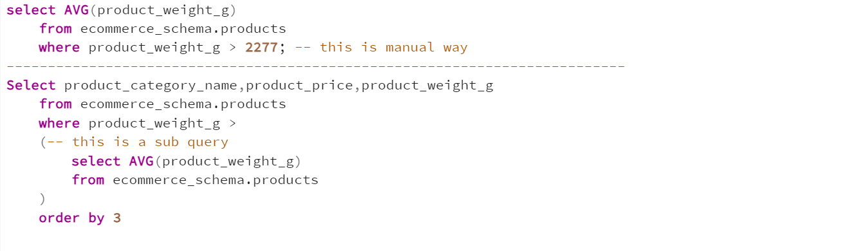

Finding max price product

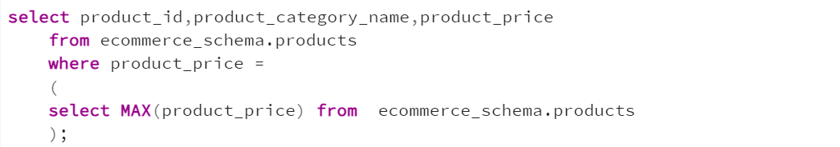

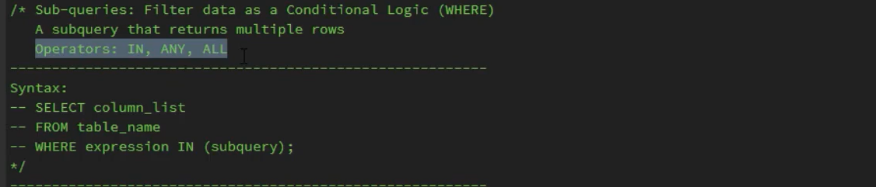

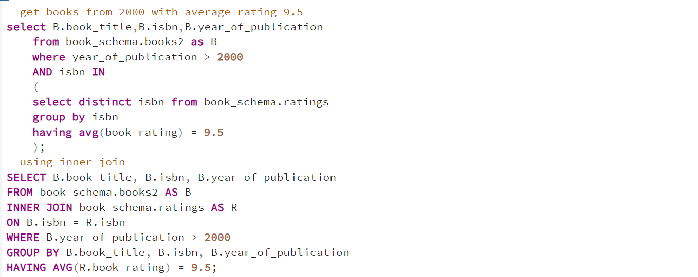

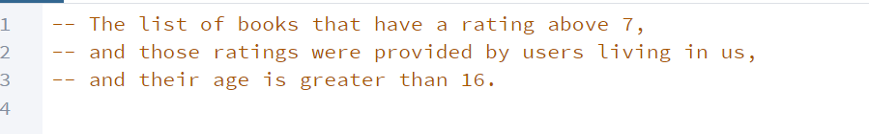  
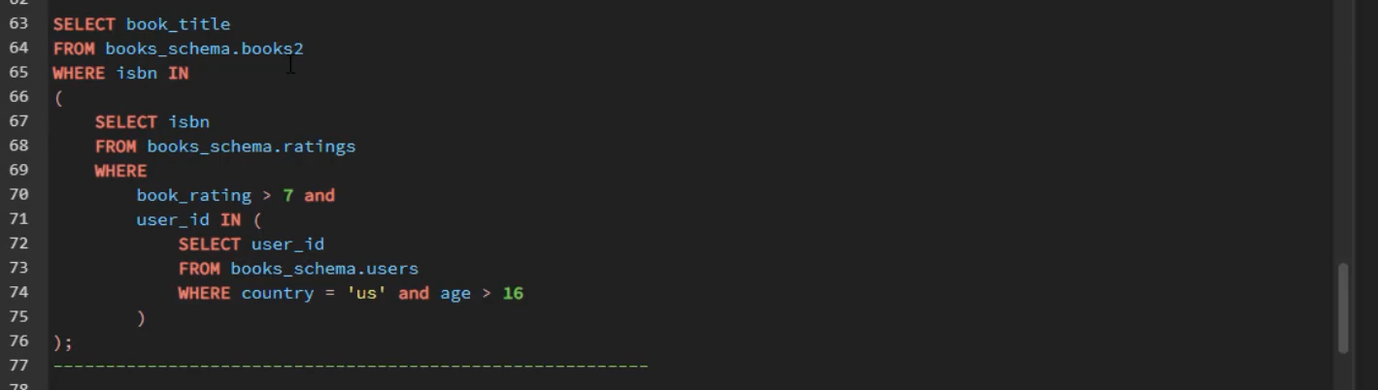

1. Conditional logic – multiple rows

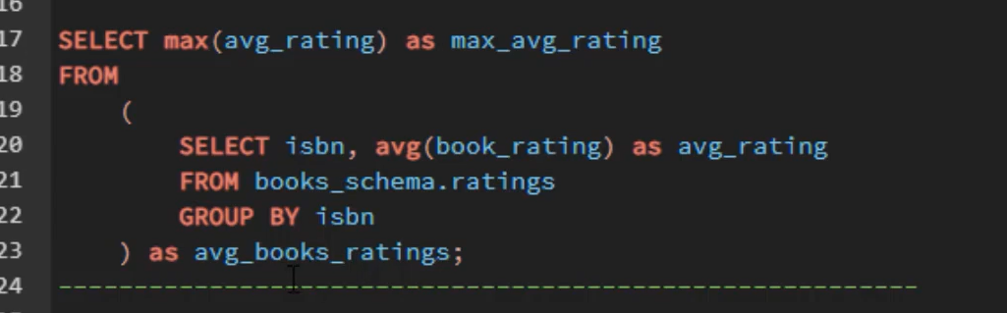

# Conditional logic - CASE

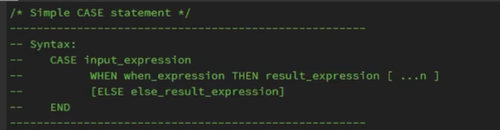

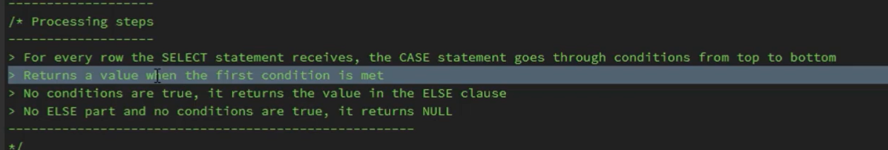

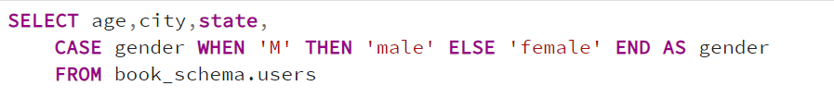

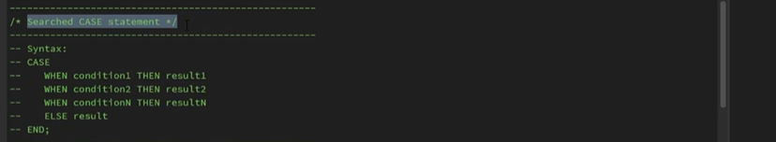

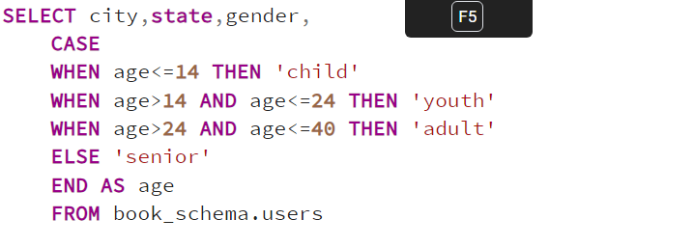

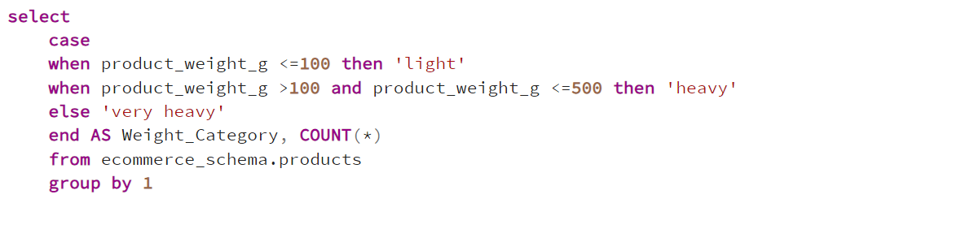

# SQL window functions

1. single

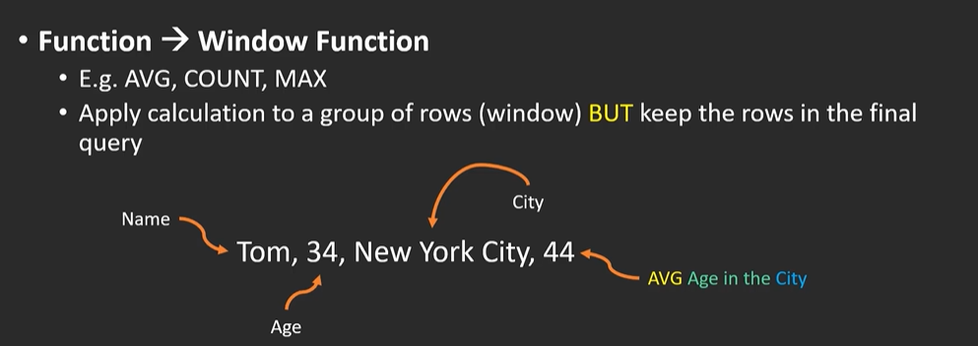

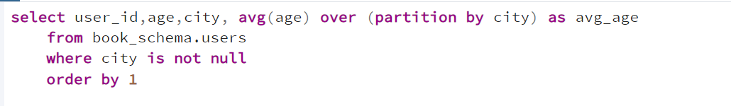

1. row number

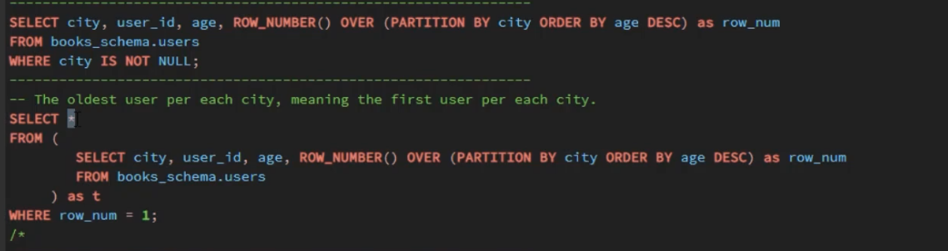

1. rank

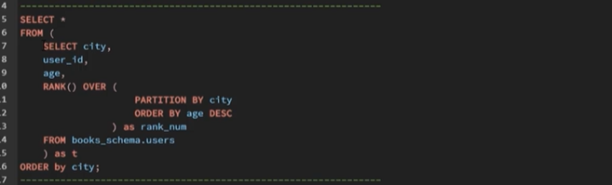

# VIEWS

